**What is Layered Architecture?**

Layered architecture is one of the architectural patterns based on call-and-return style

Layered architecture provides a clean separation between the business implementation, presentation and data-access logic.

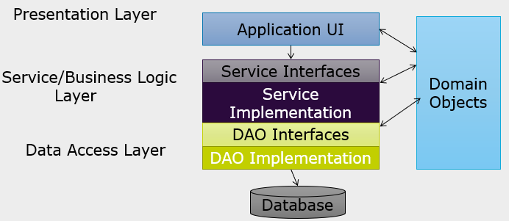

**Presentation Layer**

Presentation layer consists of objects defined to accept user input and to display application outputs

Exception handling is also an important responsibility of this layer.

Presentation-layer simply request service/business layer for required functionality by sending and receiving domain objects

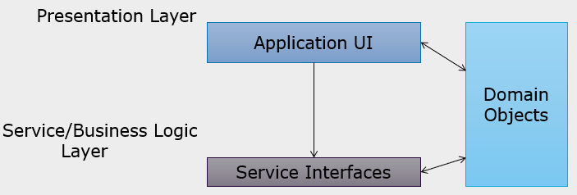

**Business Logic/Service Layer**

This layer is responsible to implement business rules and policies.

Presentation layer passes data collected from UI to business layer and interact with business logic through abstract interfaces.

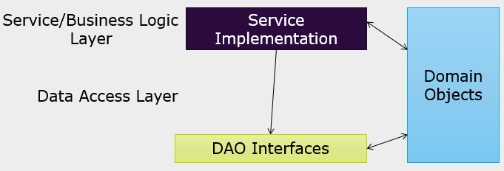

**Data Access Layer**

This layer abstracts the logic required to access the underlying data stores

It centralizes common data access functionality in order to make the application easier to configure and maintain.

Business logic layer interacts to data access layer through abstract interfaces using application domain objects

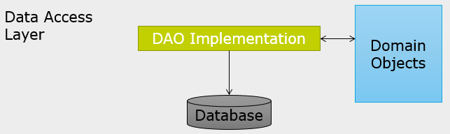

**Data Transfer Objects**

Data transfer objects (DTO) or Value Objects (VO) encapsulates business data necessary to represent real world elements, such as Customers or Orders

These objects are POJO’s to store data values and expose them through properties

They contain and manage business data used by the entire application

